# **Pomodoro Research Document**

**Recommendations:**

* For basic classification of attentiveness/inattentiveness, use alpha/beta ratio (R = alpha/beta). Perhaps with threshold determined by calibration period
* For more accurate classification, feed all band powers to a machine learning classifier (probably SVM). Include alpha/beta ratio R

**Paper 1: Dissociation between mental fatigue and motivational state during prolonged mental activity**

Low power, exploratory study

<http://journal.frontiersin.org/article/10.3389/fnbeh.2015.00176/full#B11>

* Measured mental fatigue and motivation during long sudoku tasks
* reward-induced EEG, pupillometric and skin conductance signal changes normally associated with engagement remained constant throughout the experiment and were NOT associated with mental fatigue
* Concluded that mental fatigue is not the result of a decrease in the efficiency or availability of cognitive resources
* a marginally significant increase in high gamma band activity (*p* following cluster-based correction = 0.0842) was revealed in the left frontal region (F7, FC5) after sudoku repetitions, possibly indicating a relationship to mental fatigue, but not very strong. No other bands were related

**Paper 2: Monitoring working memory load during computer-based tasks with EEG pattern recognition methods**

Old study, paywalled

<http://www-ncbi-nlm-nih-gov/pubmed/9579105>

* Neural networks trained to between EEG of subjects performing high- and low-load working memory tasks.
* Increase in midline frontal theta and decrease in midline parietal alpha associated with increased cognitive workload
* In discussion: increased frontal theta associated with sustained mental aeffort arising from ACC activation (anterior cingulate cortex, part of dorsofrontal attentional control network(?)
* ‘The magnitude of alpha activity during cognitive tasks has been hypothesized to be inversely proportional to the fraction of cortical neurons recruited into a transient functional network for purposes of task performance’‘

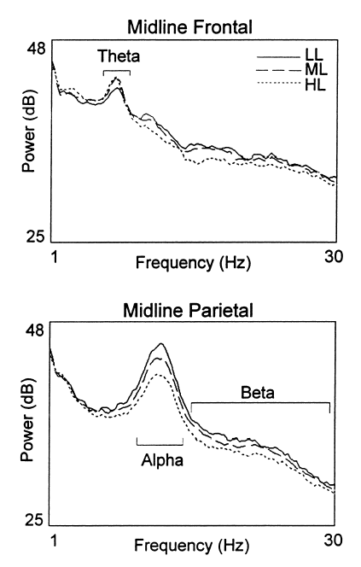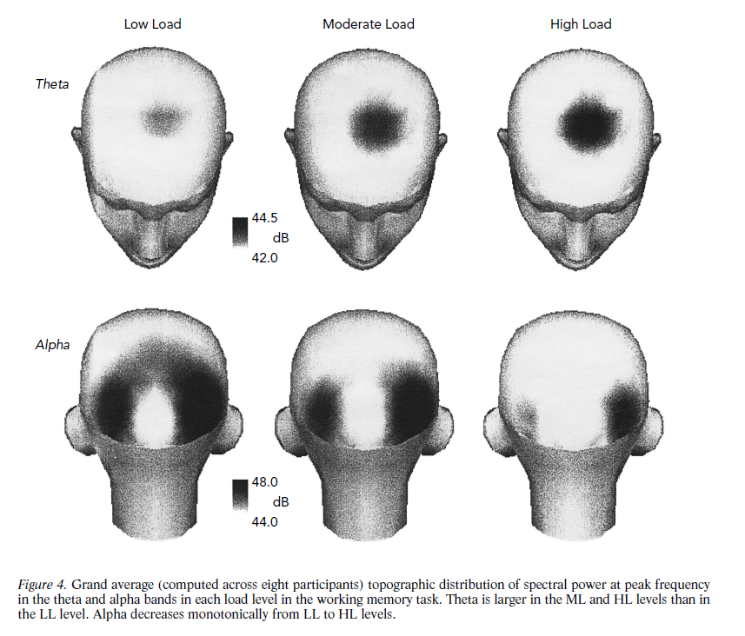

**Article 3: Detecting concentration**

Amateur, OpenBCI system

<http://eeghacker.blogspot.ca/2014/04/detecting-concentration.html>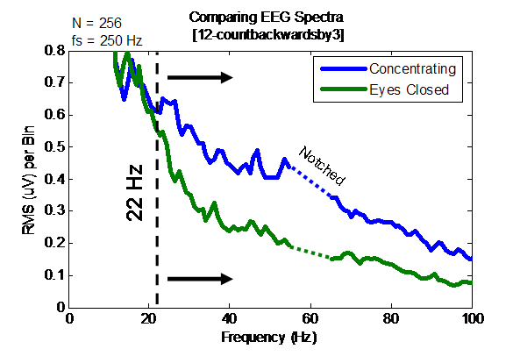

* OpenBCI setup with forehead and back of head electrodes and earclip reference
* Finds subtle increase in Beta range signal when concentrating by counting backwards by 3 from 100 with eyes open
* Finds a threshold of beta activity that seems to be associated with concentration
* Concludes that intense >2.7 uVrms beta and gamma activity might represent concentration.

Paper 4**: A Brain-Computer Interface Based Attention Training Program for Treating Attention Deficit Hyperactivity Disorder**

Uncontrolled, Conflict of interest (?)

[http://journals.plos.org/plosone/article?id=10.1371/journal.pone.0046692](http://journals.plos.org/plosone/article?id=10.1371/journal.pone.0046)

* Developed attention based neurofeedback game for adhd kids that lead to significant improvement (head band with dry sensors)
* ‘EEG studies of children with ADHD showed the majority to exhibit abnormal patterns of resting cortical activity including increased slow-wave activity (primarily theta waves), decreased fast-wave activity (primarily beta waves) and increased beta-theta ratio’
* Calculated Adhd severity measure (BASM) from EEG data collected during a Stroop task (calibration) or game play (training)
* Kind of vague about how BASM was calculated (esl? Conflict of interest?)
* ‘The BCI system then selected the band power features for maximizing the separation between attentive and inattentive states according to the information theory. A regression function would be applied by the BCI system to transform the selected features into a BASM score, which represented the severity of the inattentive symptoms of ADHD at the time of EEG recording. The BASM score was inversely proportional to the severity of the inattentive symptoms and the lower the BASM score, the more inattentive the individual was.’

Paper 5**: Recognizing the Degree of Human Attention Using EEG Signals from Mobile Sensors**

Uncontrolled

<http://www-ncbi-nlm-nih-gov.myaccess.library.utoronto.ca/pmc/articles/PMC3812603/>

* SVM classifier used to identify features best associated with attentiveness in students being taught
* Used Neurosky
* Students learning English listened to English phrases either with or without people talking in the background to provide distraction. If students agreed they were distracted, that data was included in dataset
* In a previous study, ratio of α and β activities was used as the feature for assessing the level of mental attentiveness. This only lead to 47% accuracy
* Used SVM classifier to seperate attentive and inattentive states
  + Gave training samples and used polynomial kernel functions to project feature vectors into high dimensional space before performing SVM classification
  + Used all bands (alpha, beta, theta, delta, gamma) including alpha/beta ratio (R) delta and R were most iimportant

**Paper 6: (Probably most important one): Learning EEG-based Spectral-Spatial Patterns for Attention Level Measurement**

**Abstract: Abstract— In our every day life, our brain is constantly processing information and paying attention, reacting accordingly, to all sorts of sensory inputs (auditory, visual, etc.). In some cases, there is a need to accurately measure a person’s level of attention to monitor a sportsman performance, to detect Attention Deficit Hyperactivity Disorder (ADHD) in children, to evaluate the effectiveness of neuro-feedback treatment, etc. In this paper we propose a novel approach to extract, select and learn spectral-spatial patterns from electroencephalogram (EEG) recordings. Our approach improves over prior-art methods that was, typically, only concerned with power of specific EEG rhythms from few individual channels. In this new approach, spectral-spatial features from multichannel EEG are extracted by a two filtering stages: a filter-bank (FB) and common spatial patterns (CSP) filters. The most important features are selected by a Mutual Information (MI) based feature selection procedure and then classified using Fisher linear discriminant (FLD). The outcome is a measure of the attention level. An experimental study was conducted with 5 healthy young male subjects with their EEG recorded in various attention and non-attention conditions (opened eyes, closed eyes, reading, counting, relaxing, etc.). EEGs were used to train and evaluate the model using 4x4fold cross-validation procedure. Results indicate that the new proposed approach outperforms the prior-art methods and can achieve up to 89.4% classification accuracy rate (with an average improvement of up to 16%). We demonstrate its application with a two-players attention-based racing car computer game.**

**Other papes worth looking in to:**

<http://journal.frontiersin.org/article/10.3389/fnhum.2011.00070/full>

<http://www.ncbi.nlm.nih.gov/pmc/articles/PMC3155983/> (model able to distinguish between distracted, low engagement, and high engagement during performance of cognitive tasks)

<http://www.sciencedirect.com/science/article/pii/S0301051113002421> (‘frontal theta turned out to be a reliable marker of distinct changes in cognitive processing with increasing fatigue.’)

<http://onlinelibrary.wiley.com/doi/10.1111/j.1469-8986.2011.01329.x/full> (‘as a person fatigues, slow wave activity increased over the entire cortex, in theta and in alpha 1 and 2 bands, while no significant changes were found in delta wave activity)